*Class Activity*

1. Total orders placed, credit card number, name and DOB
2. One to Many (A singular order can only be ordered by one person)
3. 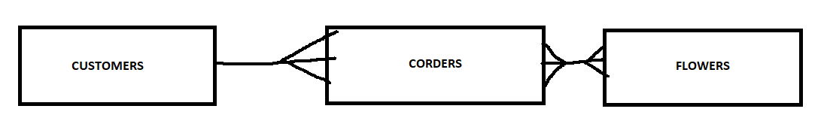Entity diagram:
4. 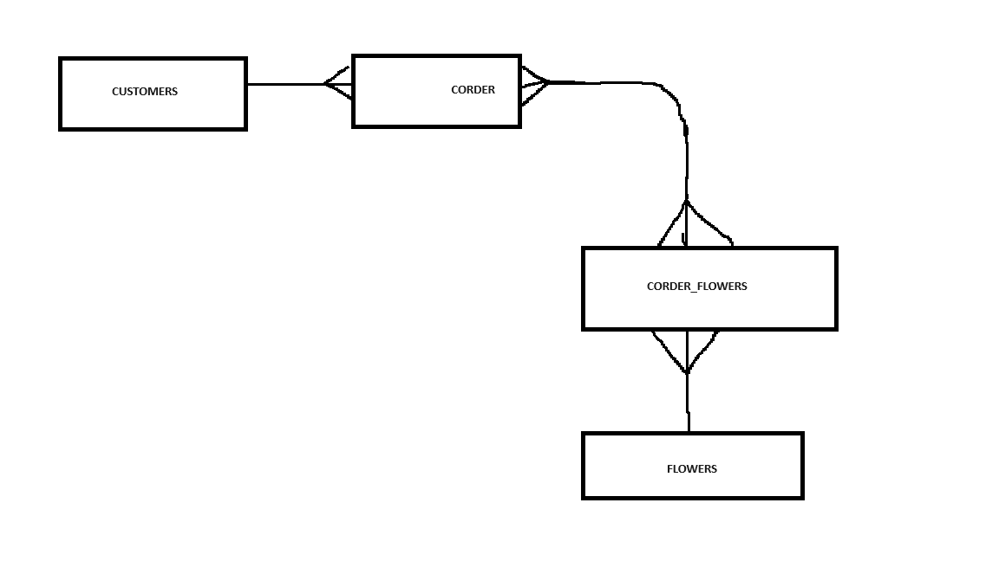Here we’ve fixed the error of the direct many-to-many line and instead broken it down into two one-to-many lines.